From assessment

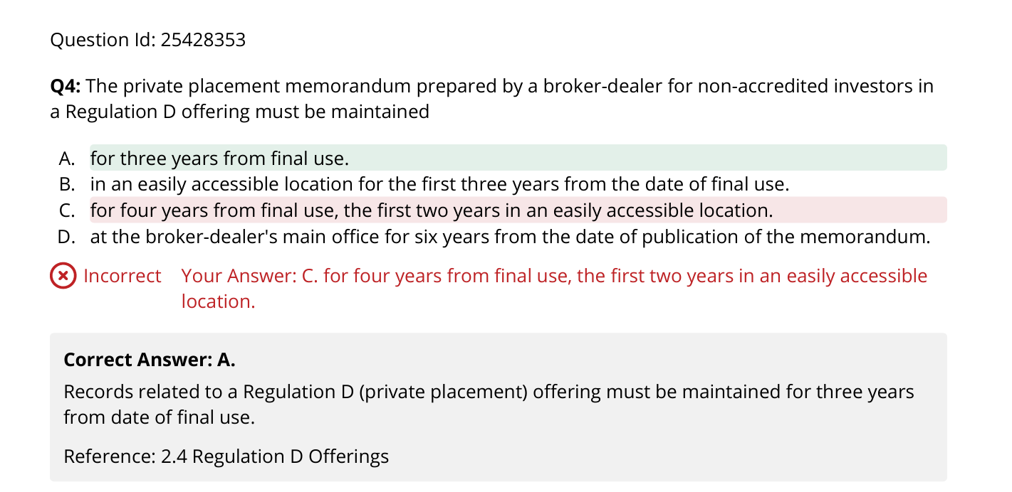

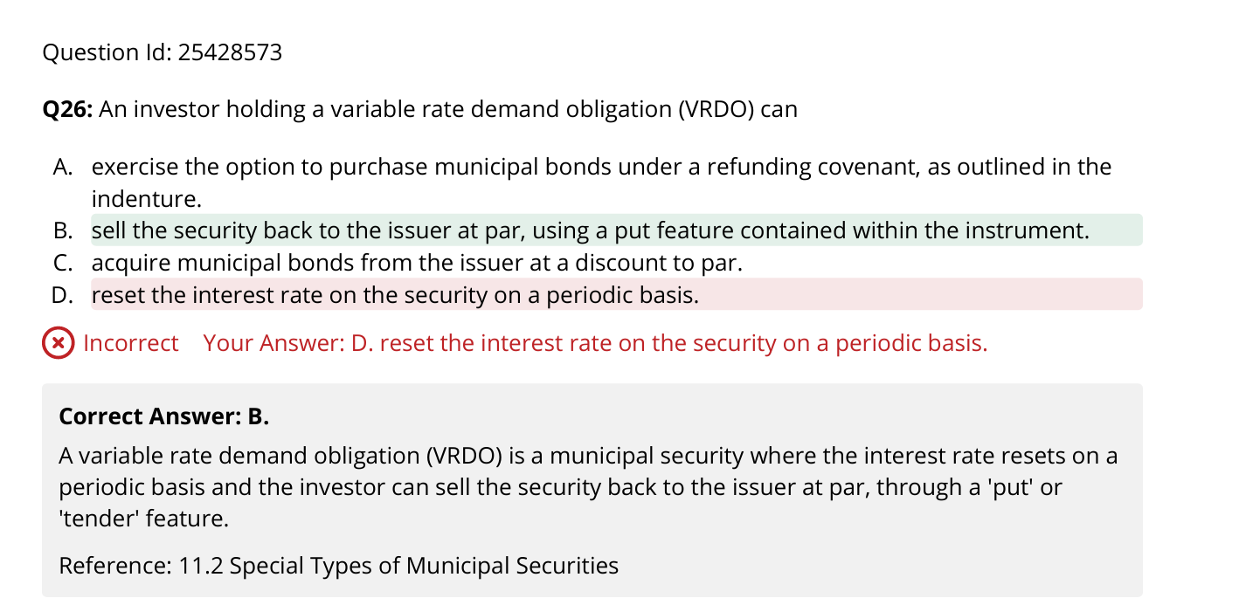

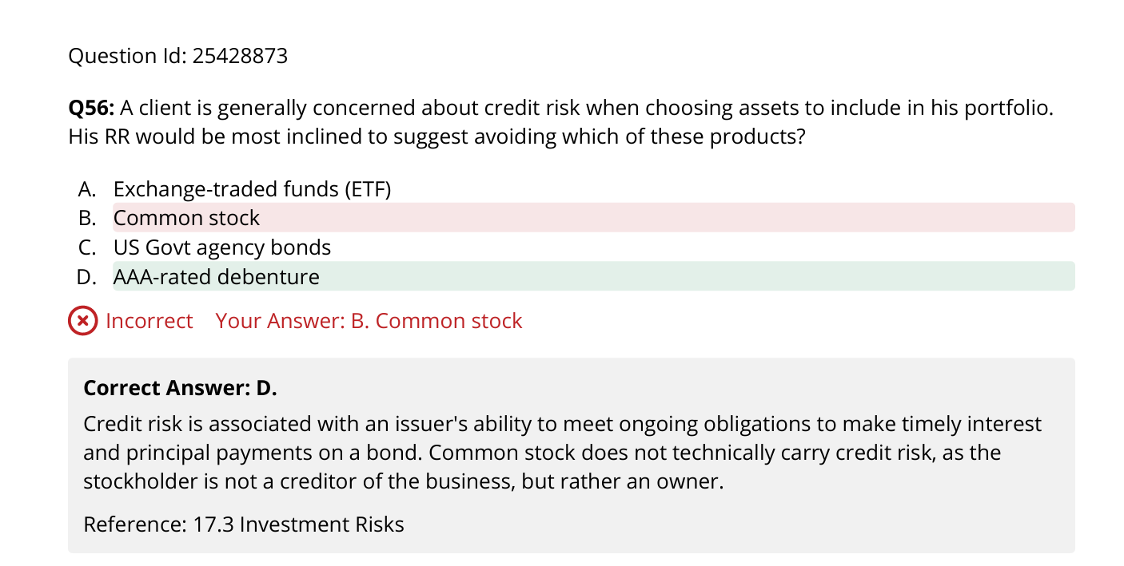

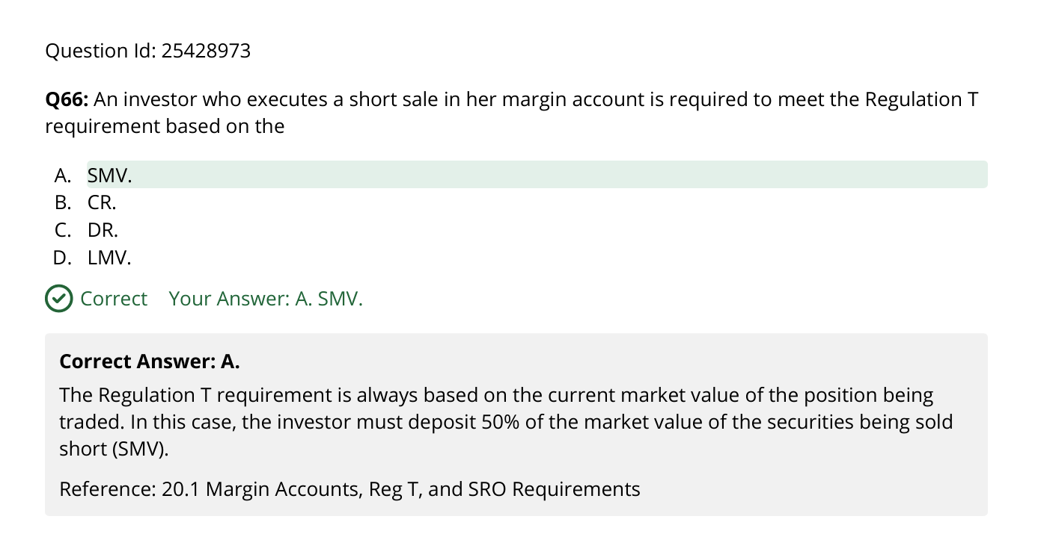

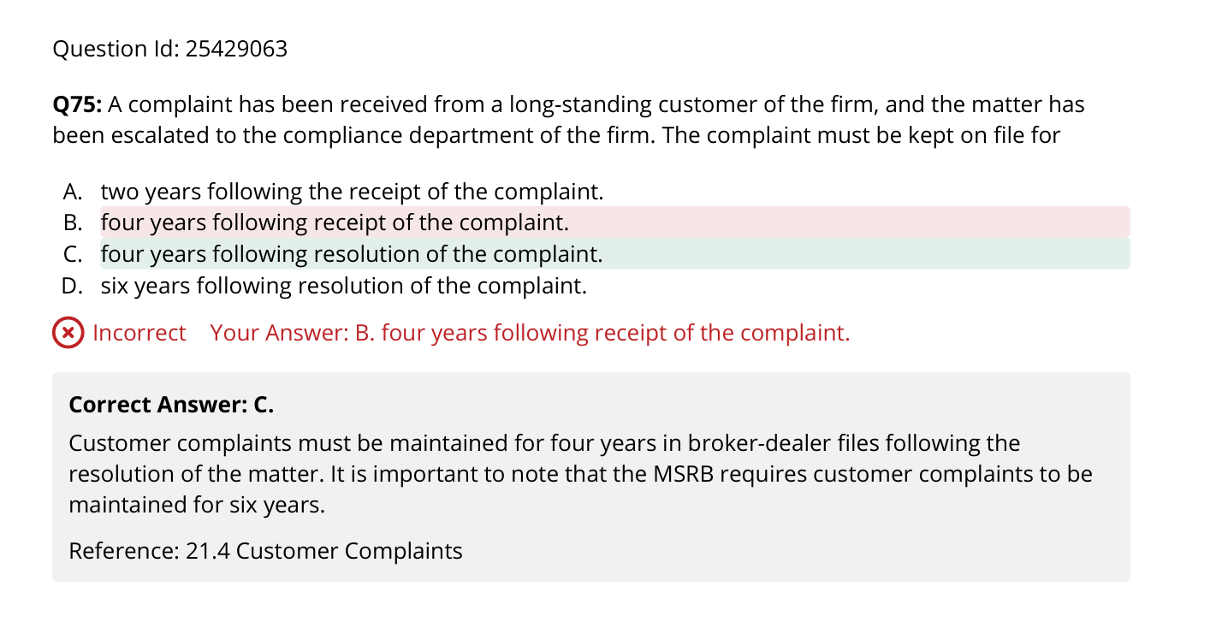

Actual diag 1 final

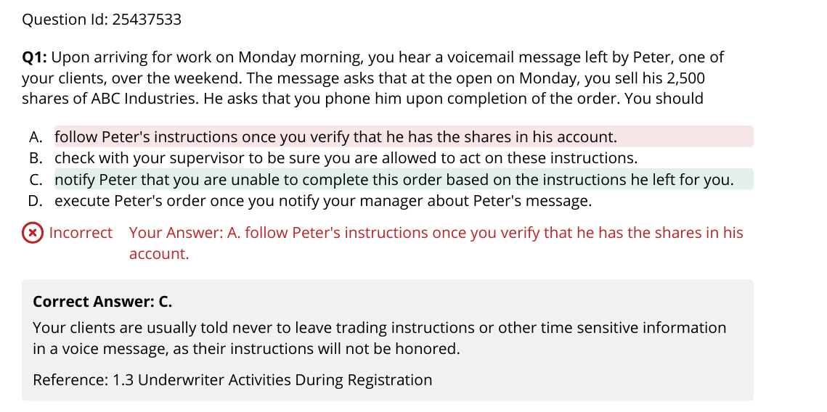

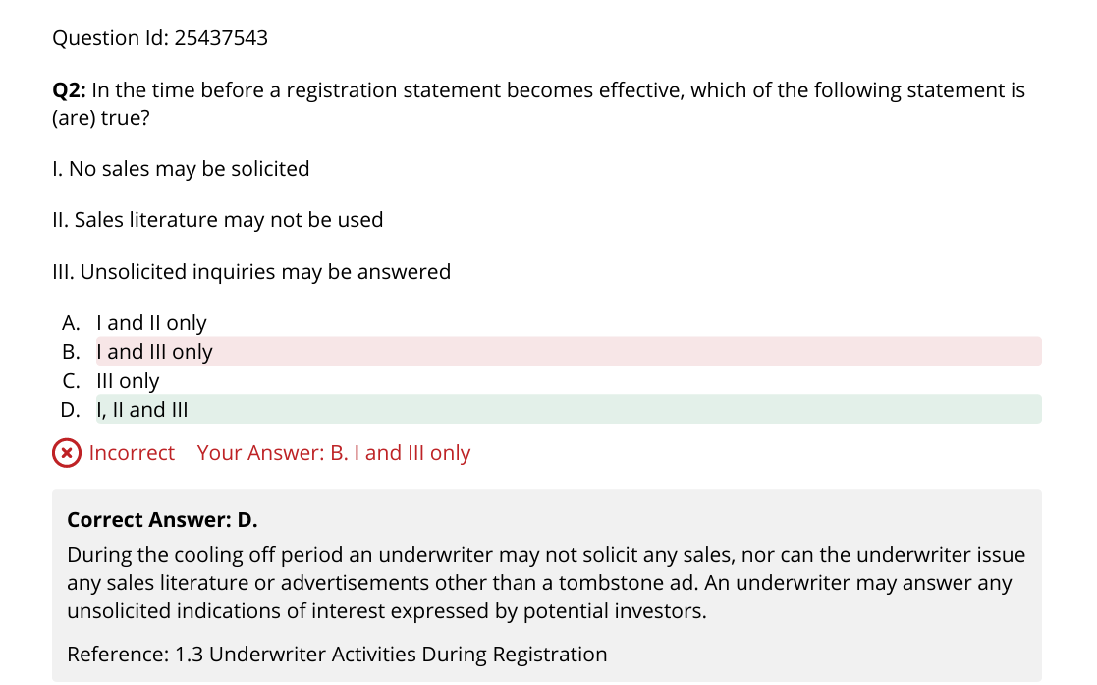

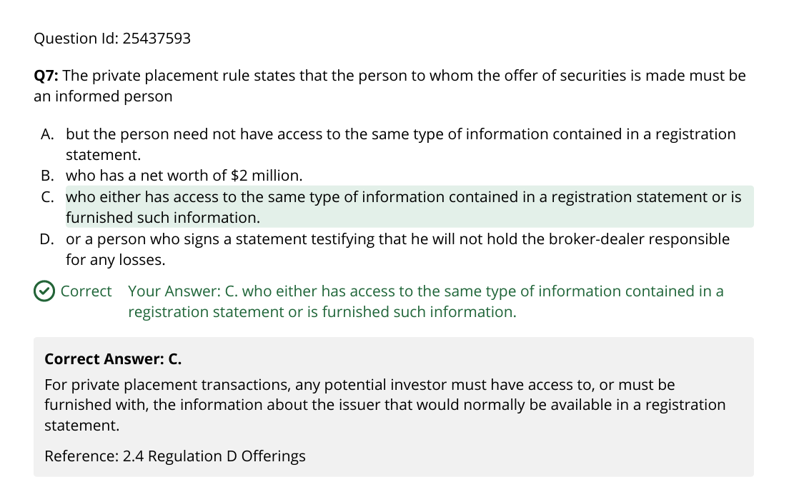

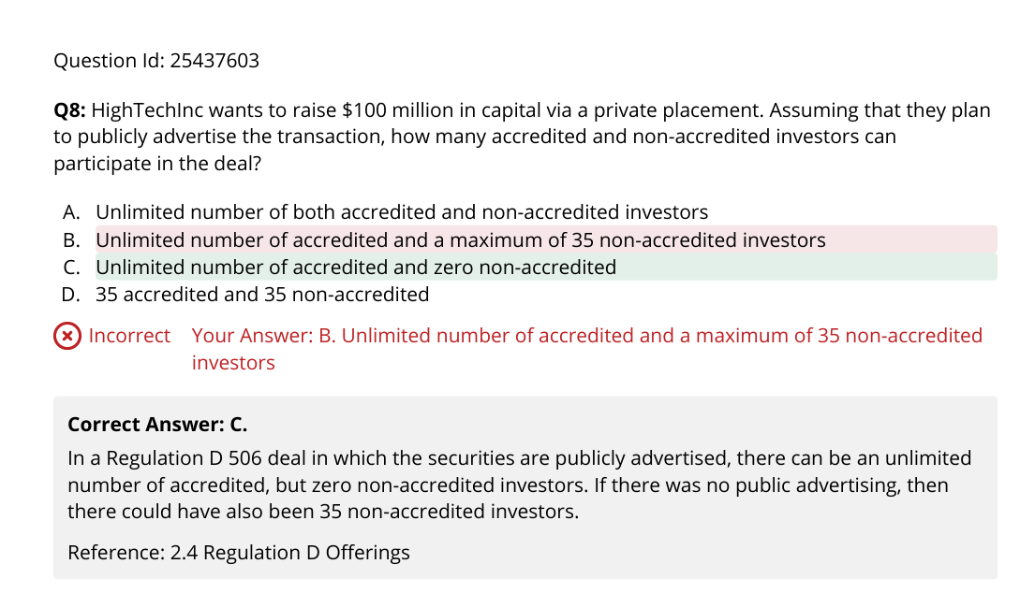

506(b) has no ad and (c) has ad

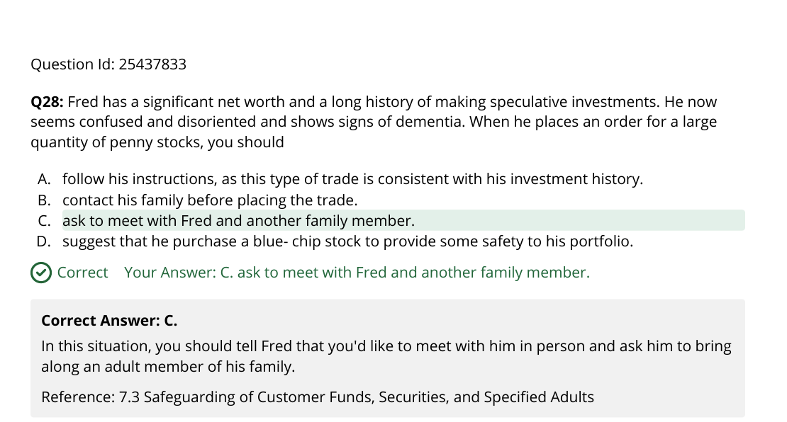

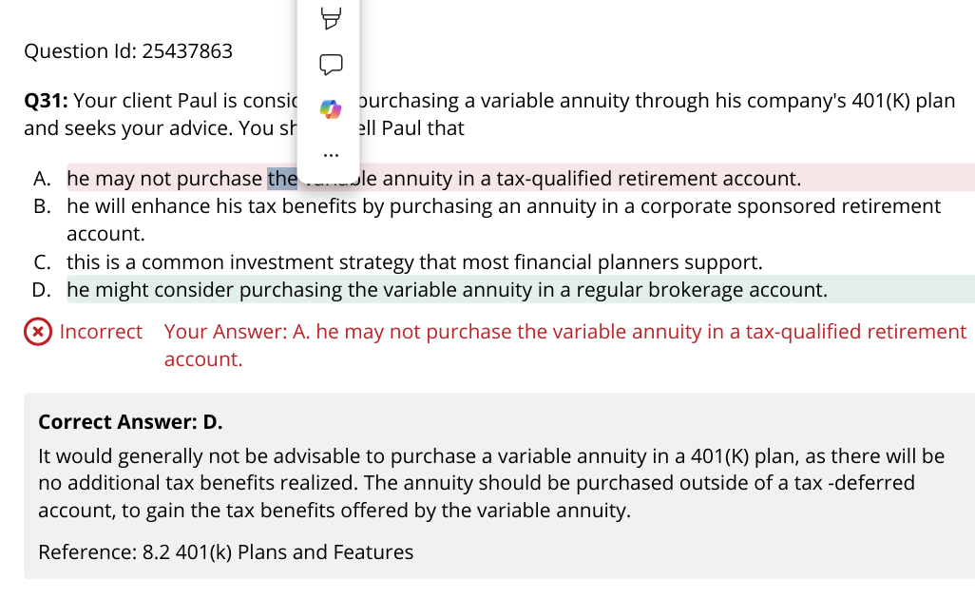

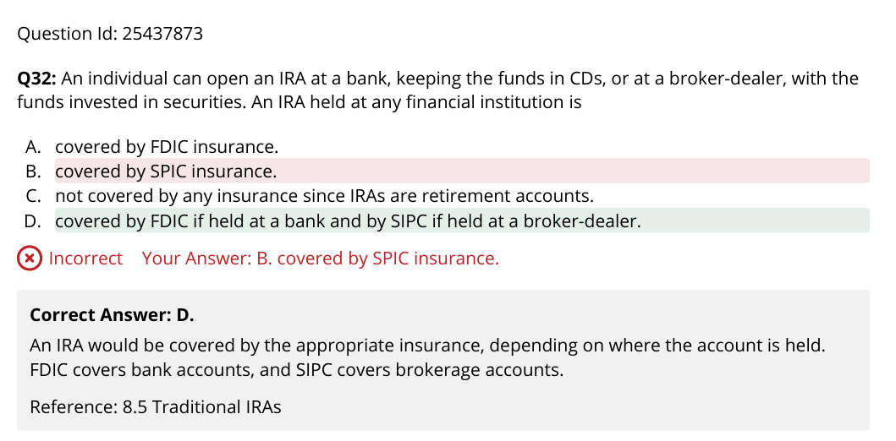

It said it is holding CD => thus FDIC

Wash-sale does not care about direction buy/short.

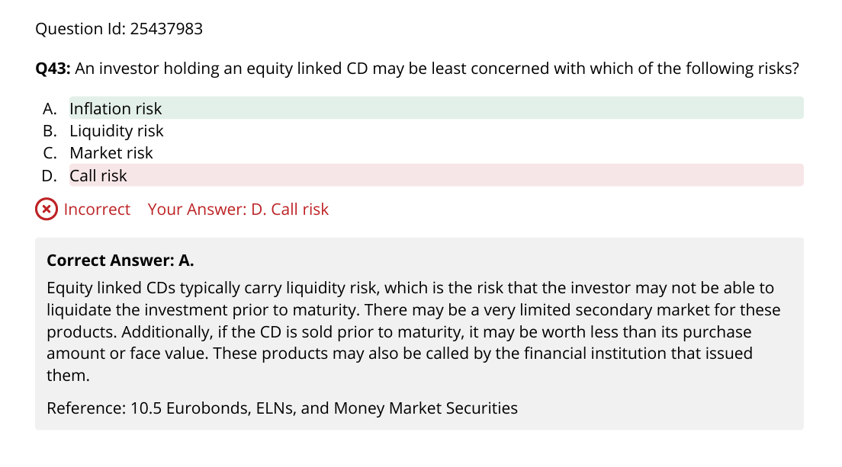

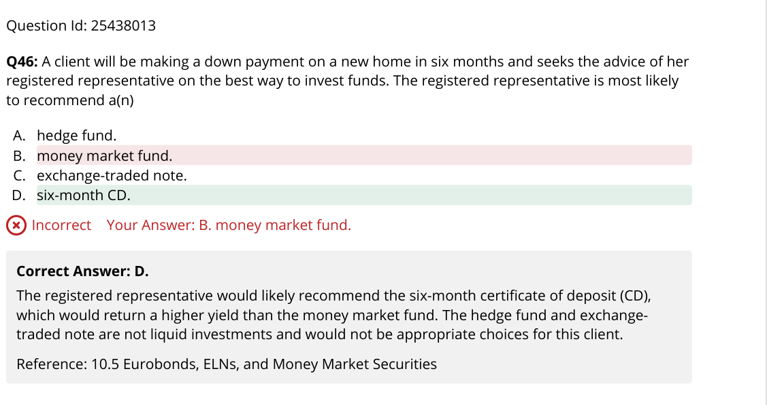

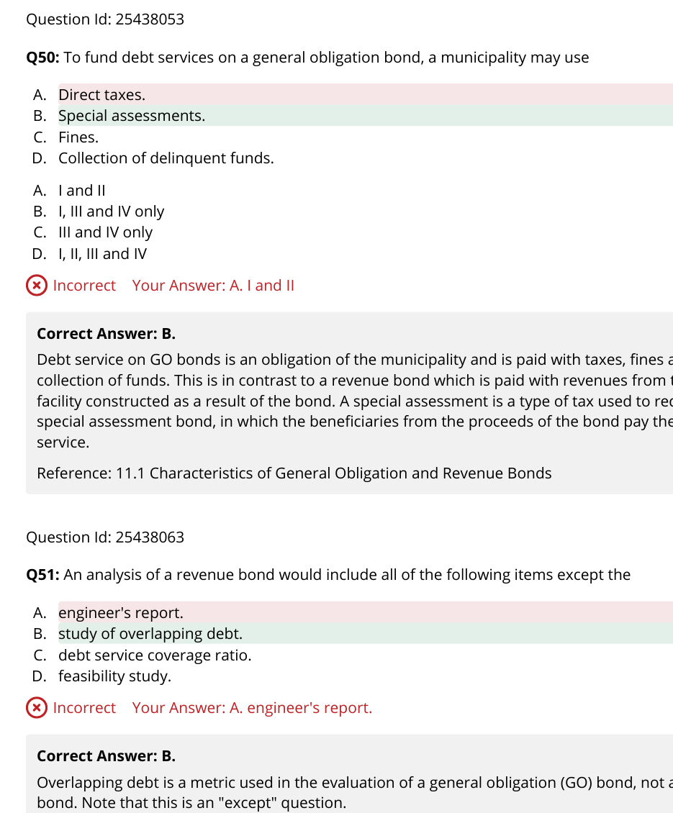

SP is a bond which is residents pay assessment cost to improve on the sidewalk.

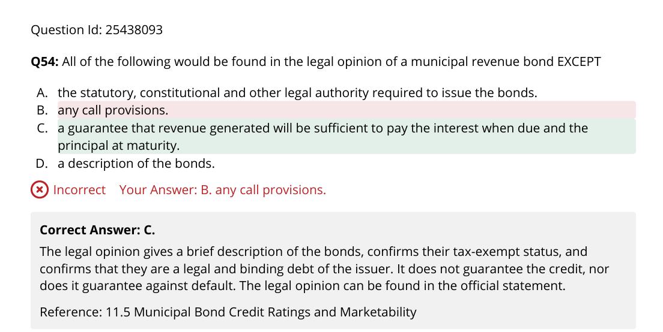

Debt service ratio = [Earnings before Interest & Taxes (aka EBIT)]/(Principal + Interest due).

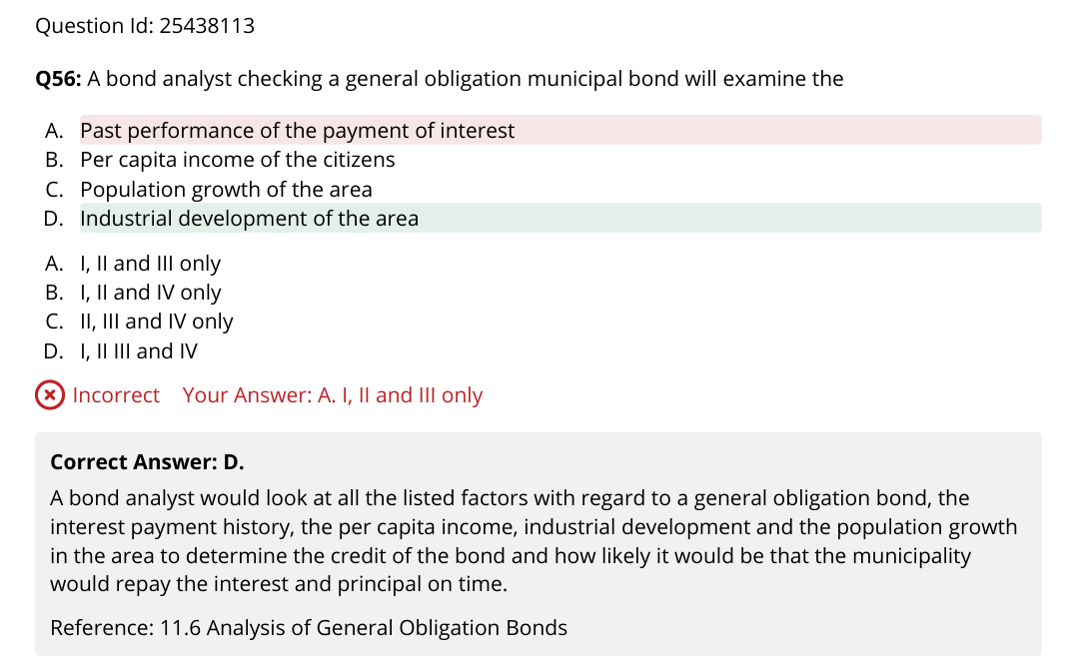

Secondary mkt buy muni, discount bond then just simple capital gain, premium use amortization adjustment.

Distributions from a Real Estate Investment Trust are subject to regular income tax, unlike ordinary cash dividends from common or preferred shares, which may be subject to regular tax liability depending on the length of time the shares were held surrounding the ex-dividend date. If the shares were held for at least 61 of the 121- day period s

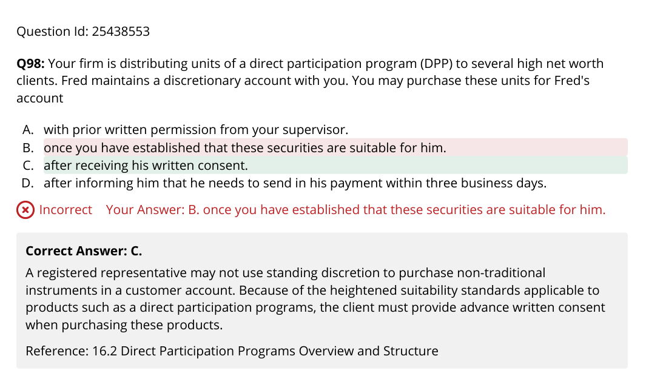

DPP to who can make use of the tax benefit not to low tax bracket. To sophisticated investors.

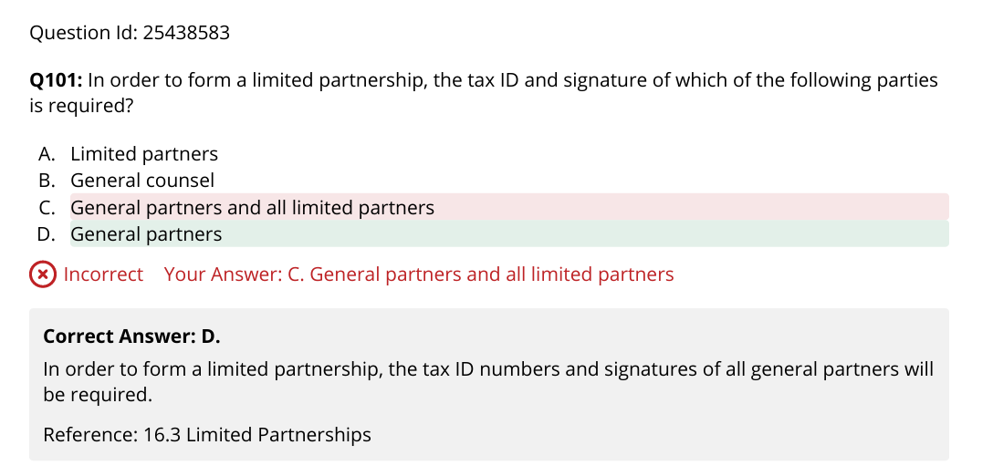

GP=sponsor review and approve LP’s sub

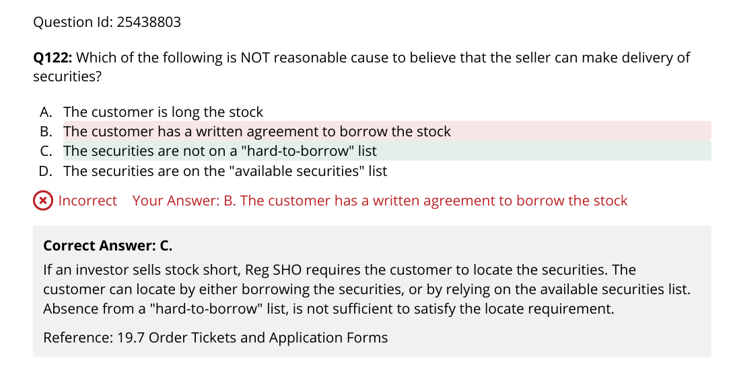

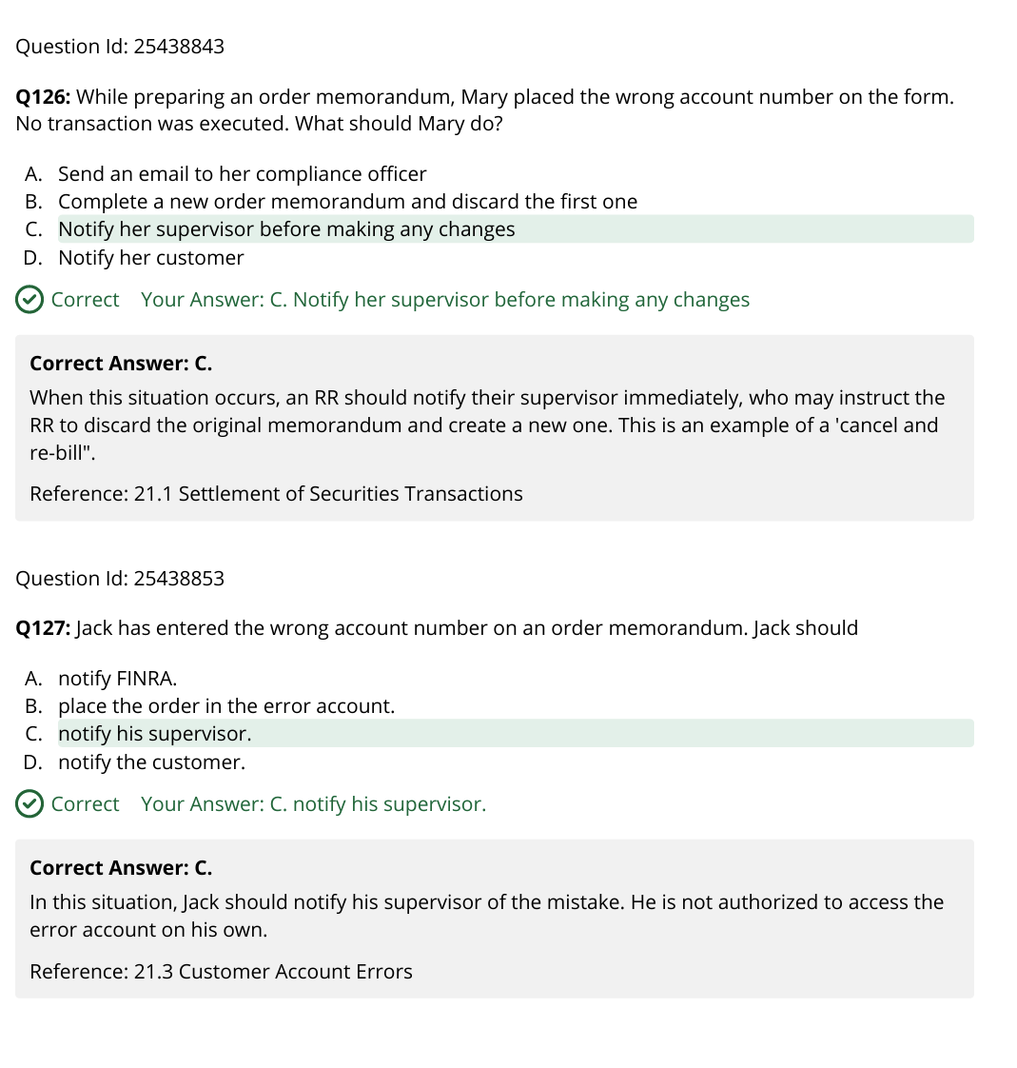

Diag 2

Go bidding, rev negotiated

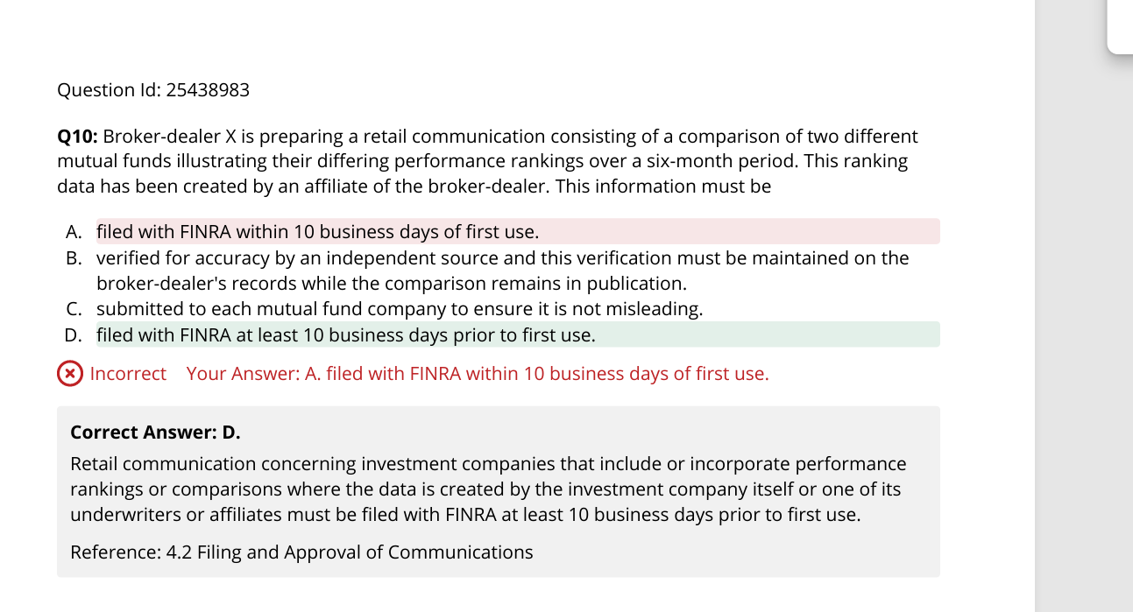

What is required for 10 days.

It is not necessary to have information about a client's educational background in your customer account records

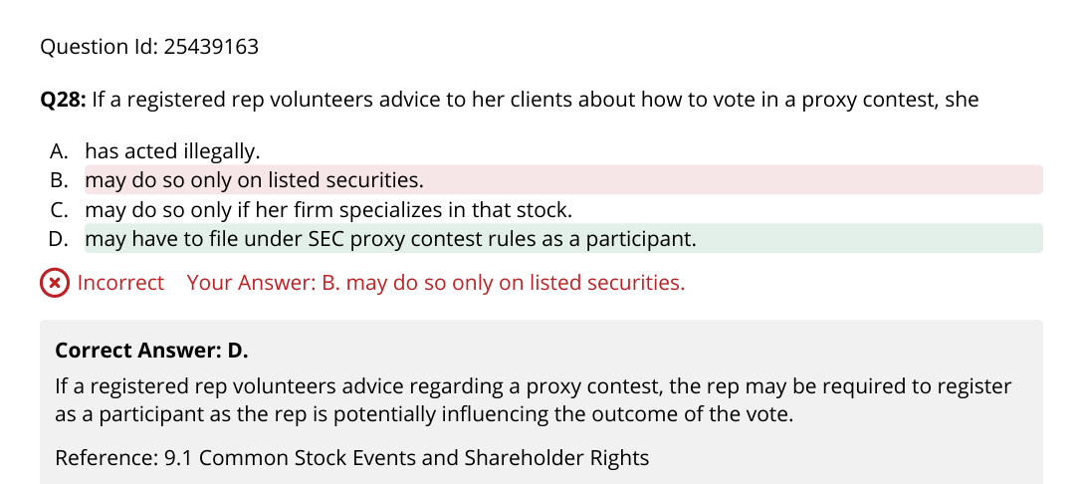

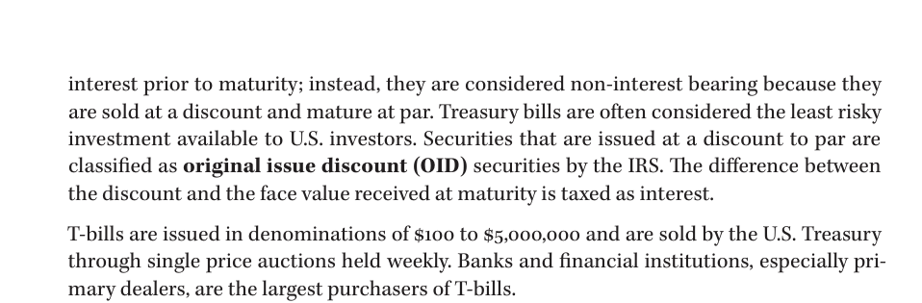

A special tax bond is generally backed by a tax on a complimentary product. A fuel or gas tax might be earmarked as the backing on a highway renovation bond

Limited tax is for go, like 1% increase in sales tax to build a bridge

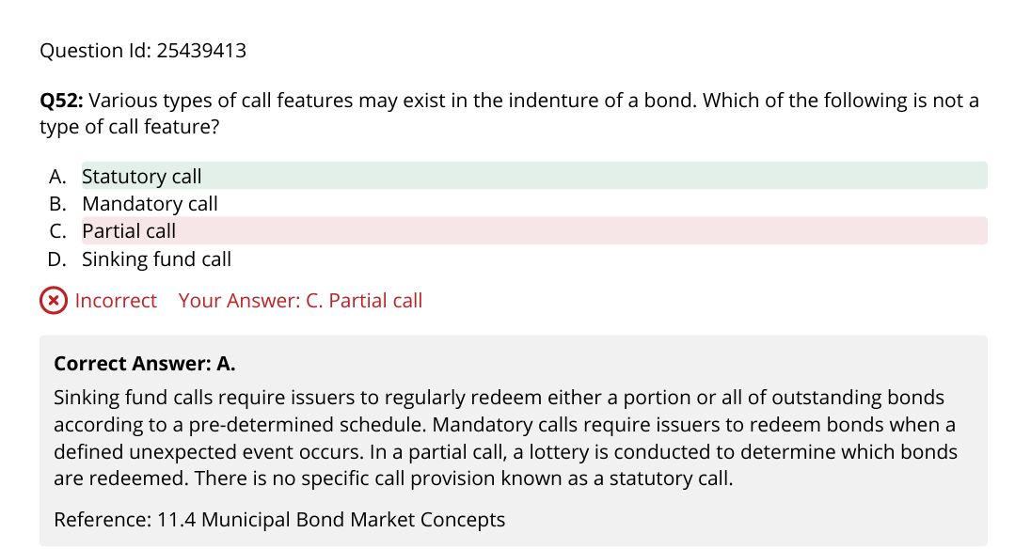

In-whoel vs part. Opytional, mandatory extraordinary sinking fund make whole.

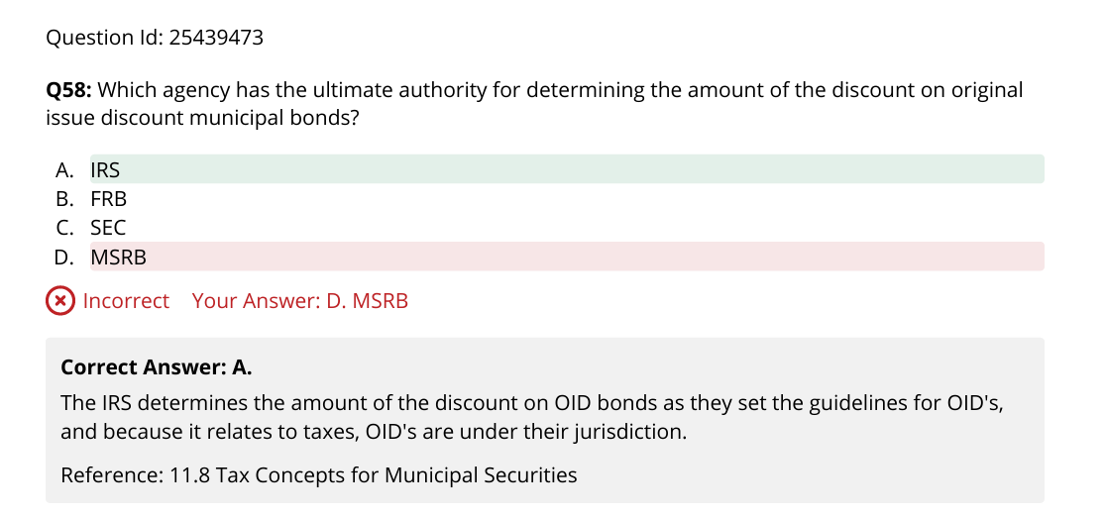

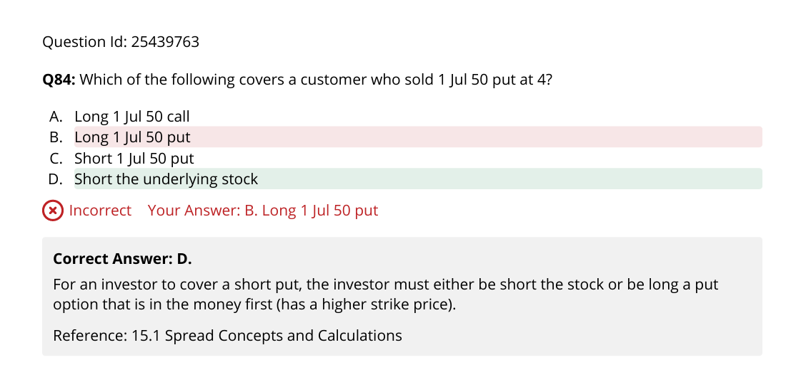

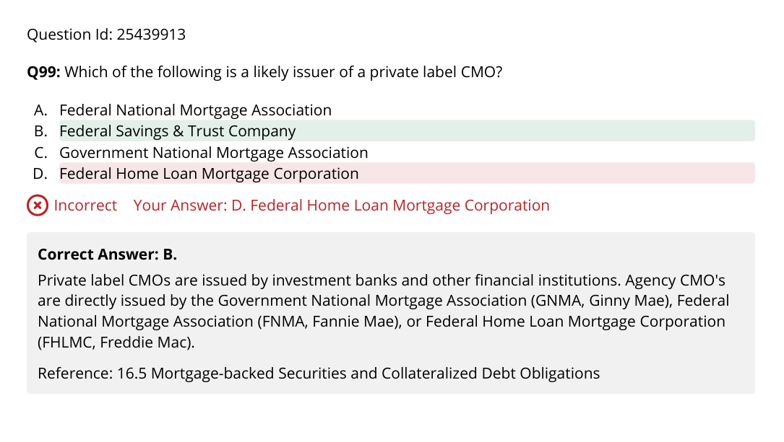

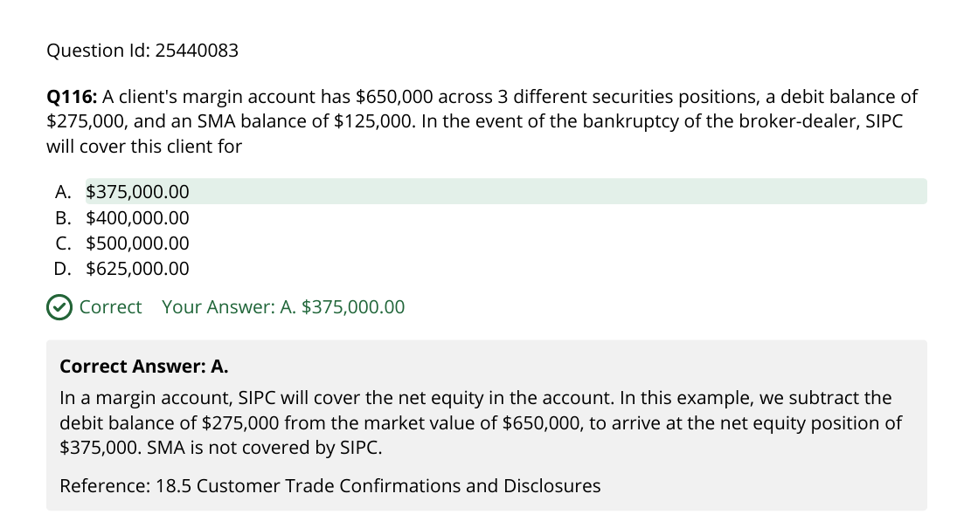

Securities regulations prohibit the placement of orders to buy or sell securities in increments of less than $.01. This applies to all securities priced for at least $1.00. Orders are not rounded up or down

Targeted quiz 1

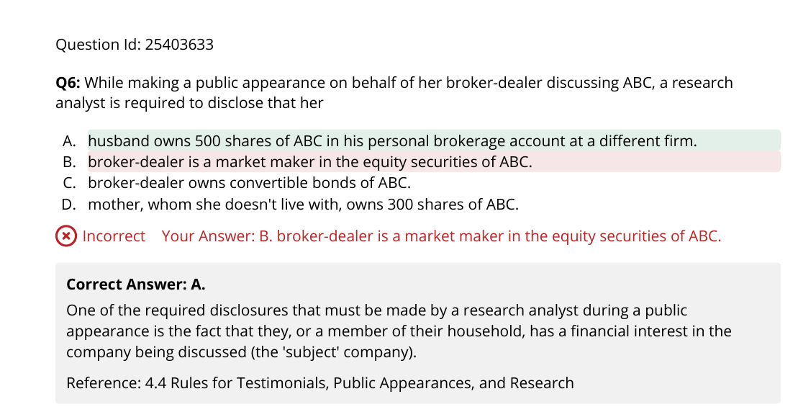

Pre-filing for retail communication

With tables/rankings, or any comm new firm. Otherwise post-filing. No filing for institutional, non-investment company on national exchange, educational material.

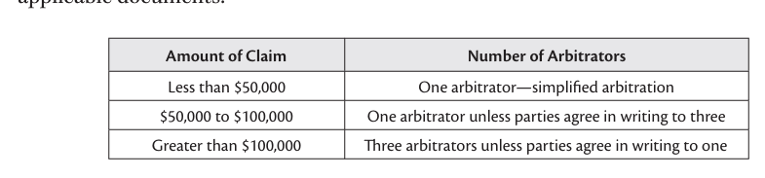

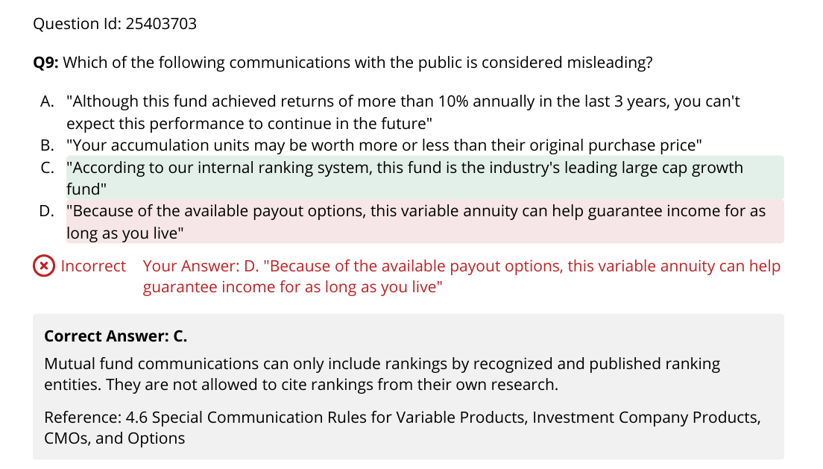

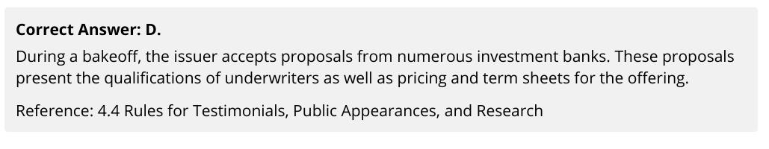

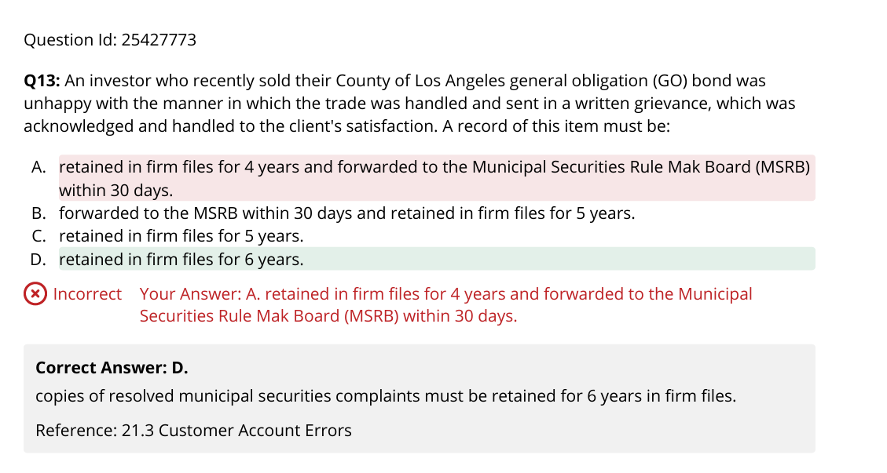

Finra wa 4 years.

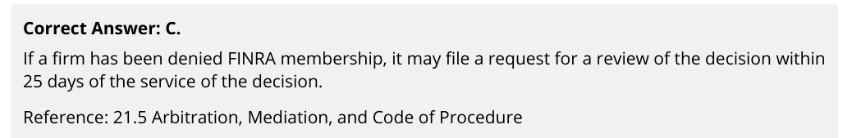

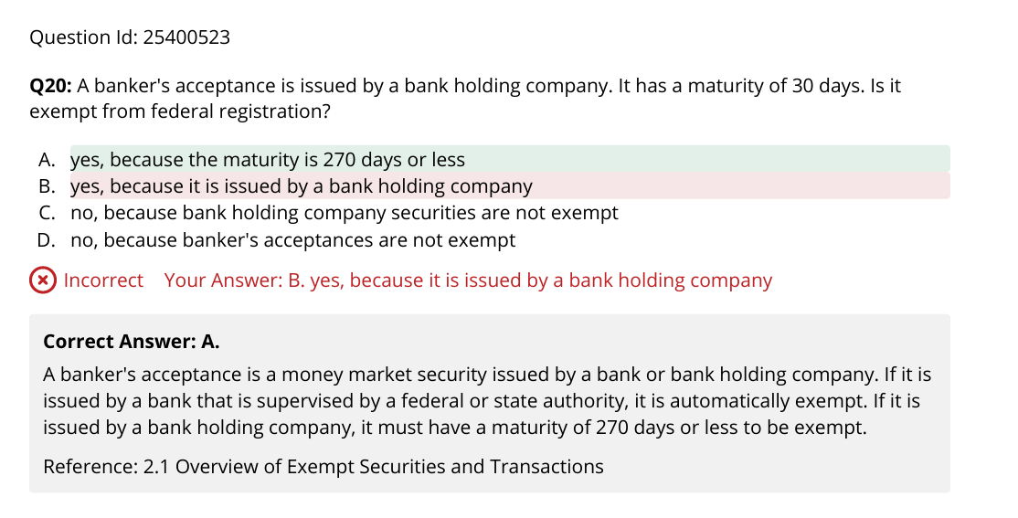

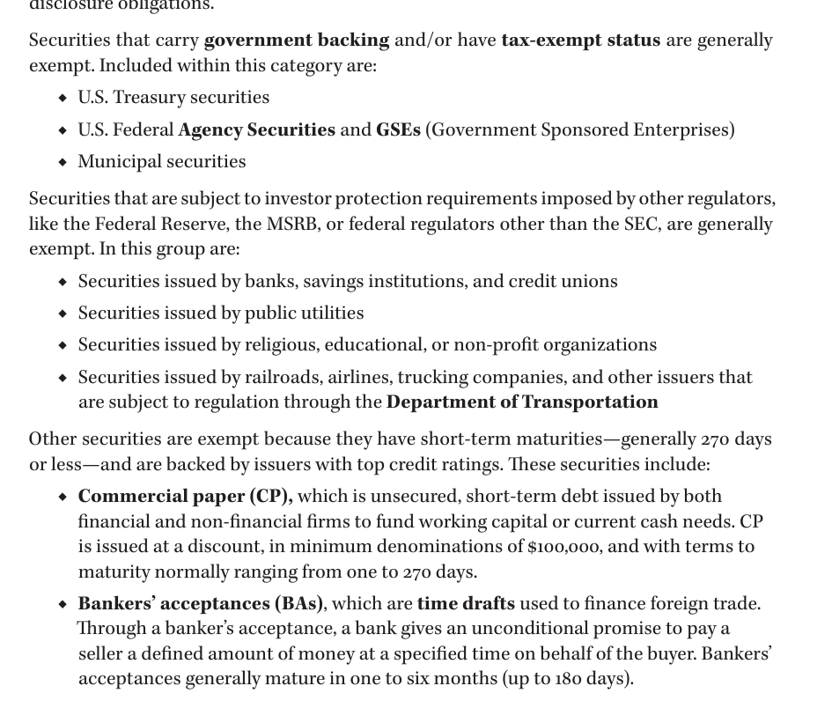+CD

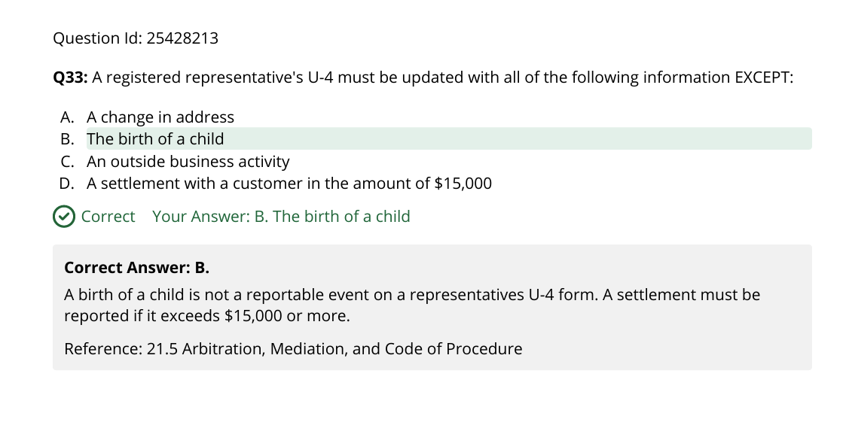

Illustration != projection !!!!!

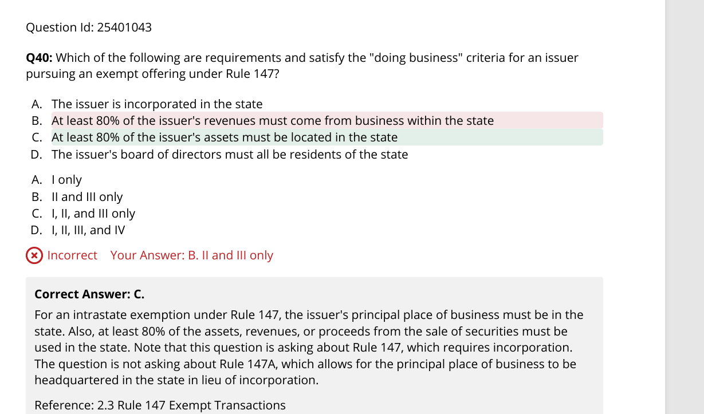

147A intrastate crowdfunding. Keyi adv to out-of state keyi incorporated oos

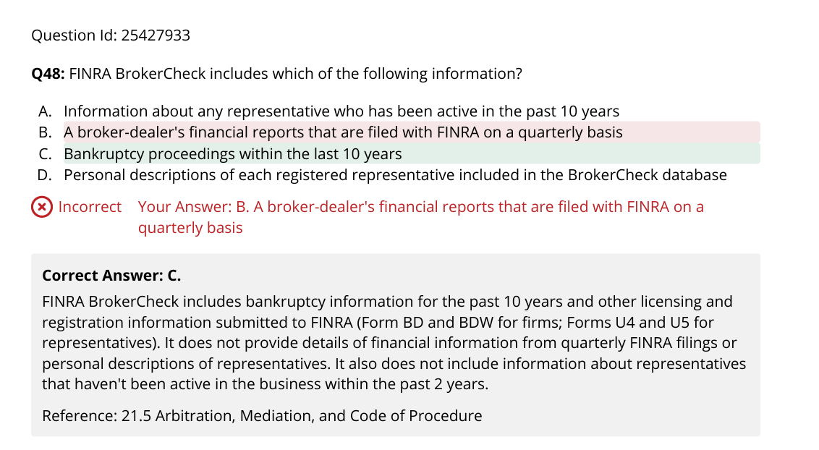

Offering Circular is for RegA may or may not require the corp financial